Introduction to the Internet Archive
The Internet Archive contains over 8 million texts freely available for download. The content is a combination of publications scanned through mass digitisation projects by e.g. Google and Microsoft, institutional digitisation initiatives and material contributed by individuals.
The National Art Library is in the process of uploading a small group of early Museum publications, the South Kensington Museum Art Handbooks, and this project is now virtually complete. We scan the books and forward simple PDFs to the Internet Archive (IA) together with the relevant metadata. IA then applies an optical character recognition programme to make the text searchable and also renders it viewable in page turning software.
An example is: ‘Persian Art’ by Robert Murdoch Smith
Googling ‘Internet Archive Texts’ brings you to this page

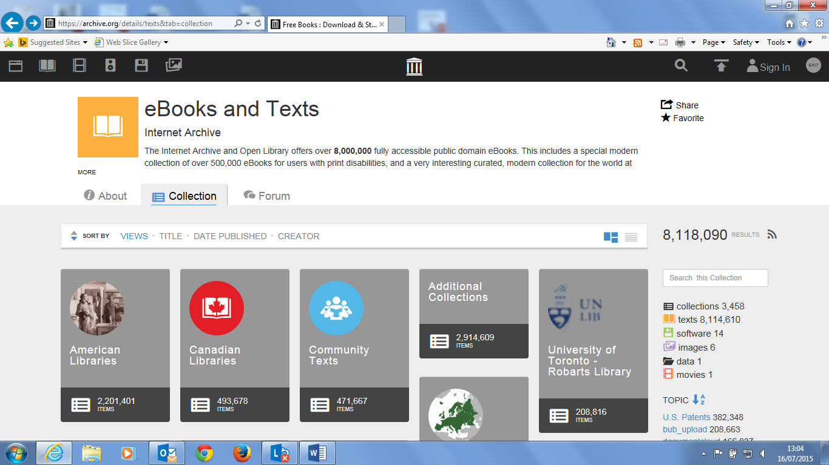

Clicking on the search button here allows you to search for a book on a specific topic.
These search terms were used to find the book ‘Persian art’ uploaded by us.
Clicking on the title link will open up the eBook (see next slide)
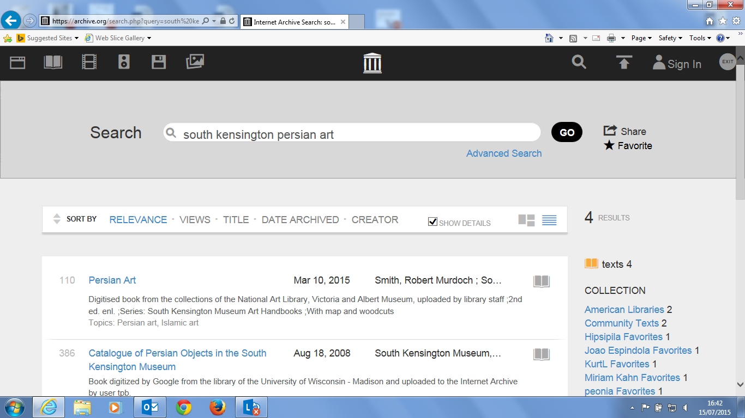

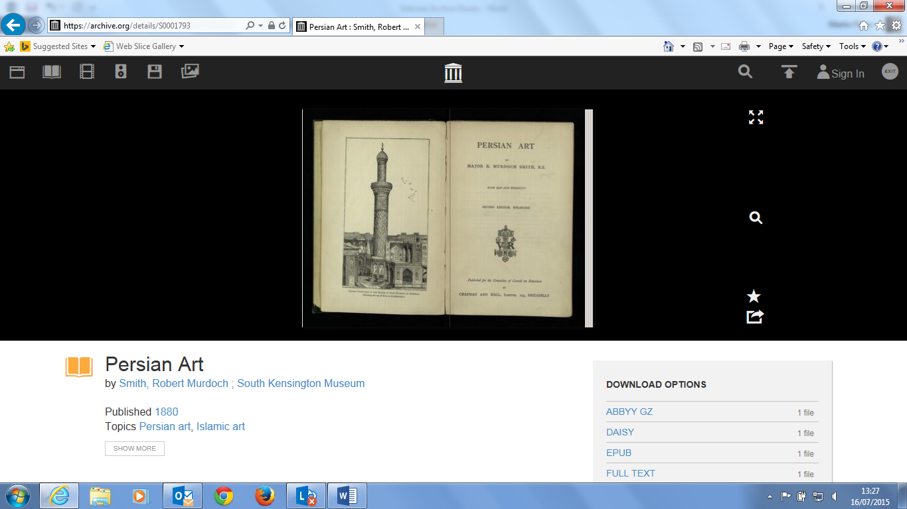
Clicking the ‘fullscreen view’ icon will open up a full page view of the text
Clicking the ‘Search inside’ icon will allow you to search for a term inside the book.
A search for ‘porcelain’ shows this full screen format with a tag for each occurrence of the word within the text.
Clicking on any of these ‘search result’ tags will bring you to the relevant reference to the word.
The word is also highlighted in blue on the page.
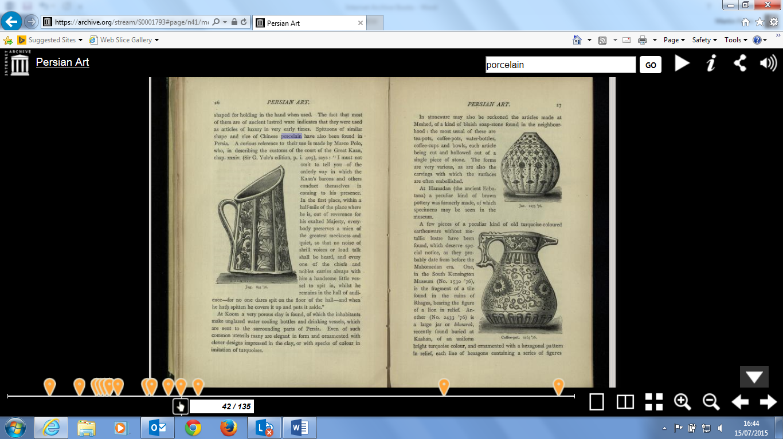
Metadata for the text appears below the book as follows
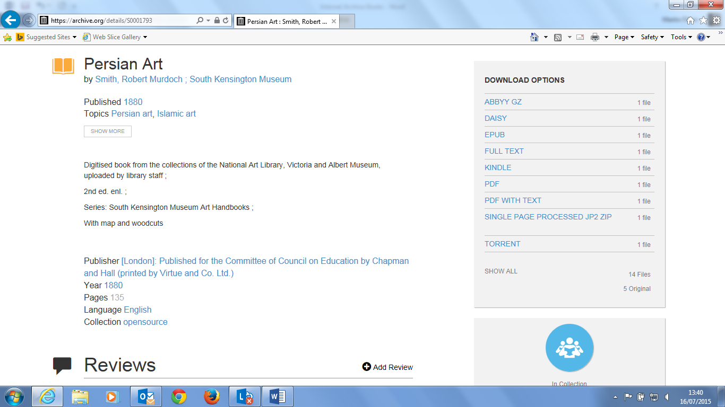
These are the range of possible formats for downloading the book to your own device
We have embedded a link in the National Art Library catalogue to the Internet Archive copy of the book as below and clicking on this link opens the work in the Internet Archive and provides all of the functionality described above.

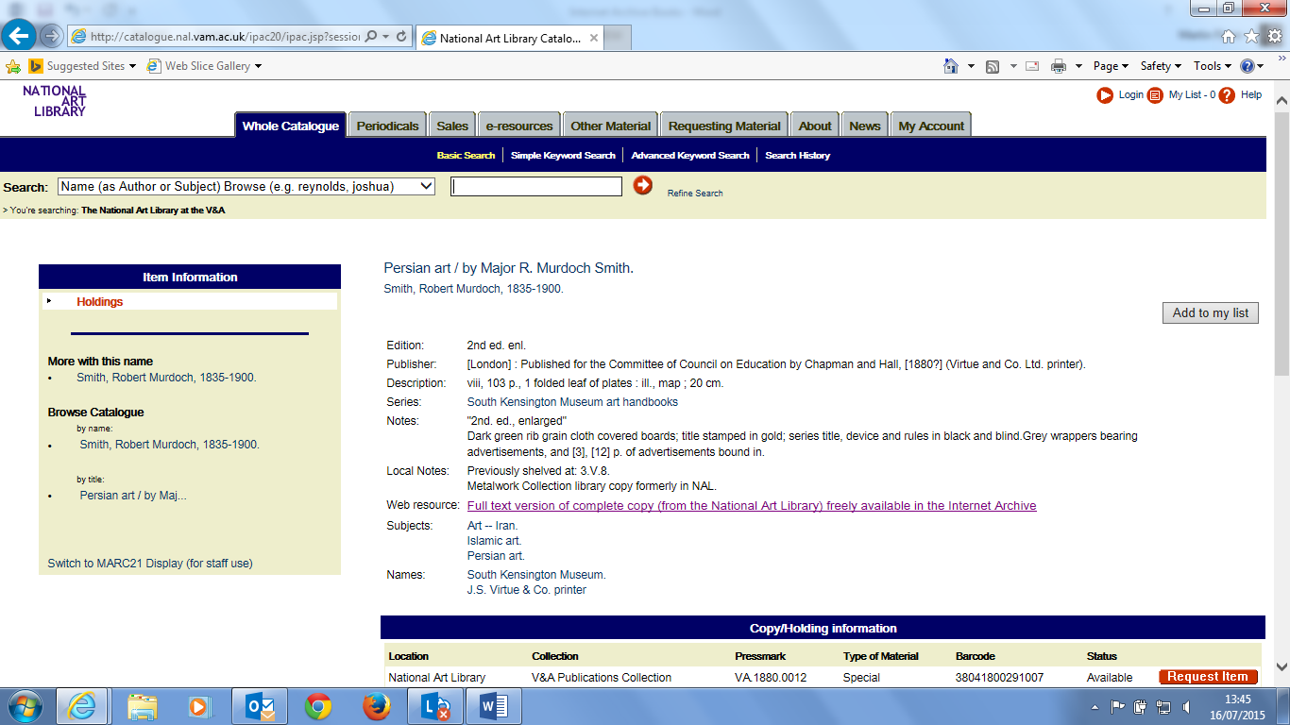

The Internet Archive also provides us with a range of administrative functions including the level of use of the eBook. ‘Persian Art’ was uploaded by us in March 2015 and allows us to track how many times it has been downloaded since then.

Internet Archive Introduction
Martin Flynn – June 2015

